Music Store Data Analysis
By Ashin Sarkar

Problem statement: The music store's database contains diverse and valuable information about its inventory, sales, customer preferences, and operational performance. However, extracting meaningful insights and answering specific business questions requires systematic analysis. This project aims to analyze the store's database by leveraging SQL commands to retrieve and process data efficiently. The objective is to address key business questions, uncover trends, and provide actionable insights to optimize inventory management, enhance customer satisfaction, and drive sales growth.

Q1: Who is the senior most employee based on job title?
SELECT * FROM employee
ORDER BY levels DESC
LIMIT 1
Output:-

Q2: Which countries have the most Invoices?
SELECT COUNT(*) as c, billing_country
FROM invoice
GROUP BY billing_country
ORDER BY c desc
Output:-
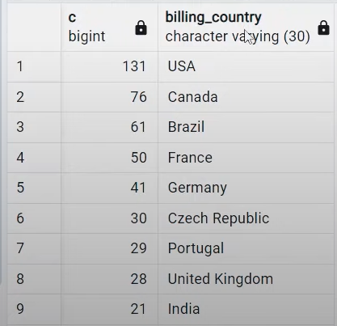

Q3: What are top 3 values of total invoice?
SELECT total
FROM invoice
ORDER BY total DESC
limit 3
Output:-
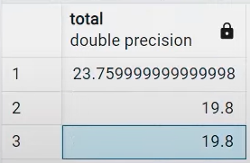

Q4: Which city has the best customers? We would like to throw a promotional Music Festival in the city we made the most money. Write a query that returns one city that has the highest sum of invoice totals. Return both the city name & sum of all invoice totals.
SELECT billing_city,SUM(total) AS InvoiceTotal
FROM invoice
GROUP BY billing_city
ORDER BY InvoiceTotal DESC
Output:-


Question 5: Who is the best customer? The customer who has spent the most money will be declared the best customer. Write a query that returns the person who has spent the most money.
SELECT customer.customer_id, customer.first_name, customer.last_name, SUM(invoice.total) AS total FROM customer
JOIN invoice ON customer.customer_id = invoice.customer_id
GROUP BY customer.customer_id
ORDER BY total DESC
LIMIT 1
Output:-
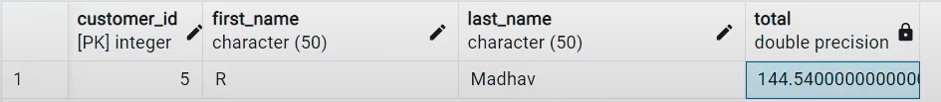

Q6: Write query to return the email, first name, last name, & Genre of all Rock Music listeners. Return your list ordered alphabetically by email starting with A .
Method 1 :
SELECT DISTINCT email,first_name, last_name
FROM customer
JOIN invoice ON customer.customer_id = invoice.customer_id
JOIN invoiceline ON invoice.invoice_id = invoiceline.invoice_id
WHERE track_id IN(
SELECT track_id FROM track
JOIN genre ON track.genre_id = genre.genre_id
WHERE genre.name LIKE 'Rock'
)
ORDER BY email;

Method 2 :
SELECT DISTINCT email AS Email,first_name AS FirstName, last_name AS LastName, genre.name AS Name
FROM customer
JOIN invoice ON invoice.customer_id = customer.customer_id
JOIN invoiceline ON invoiceline.invoice_id = invoice.invoice_id
JOIN track ON track.track_id = invoiceline.track_id
JOIN genre ON genre.genre_id = track.genre_id
WHERE genre.name LIKE 'Rock'
ORDER BY email;

Output :-


Q7: Let's invite the artists who have written the most rock music in our dataset. Write a query that returns the Artist name and total track count of the top 10 rock bands .
SELECT artist.artist_id, artist.name,COUNT(artist.artist_id) AS number_of_songs
FROM track
JOIN album ON album.album_id = track.album_id
JOIN artist ON artist.artist_id = album.artist_id
JOIN genre ON genre.genre_id = track.genre_id
WHERE genre.name LIKE 'Rock'
GROUP BY artist.artist_id
ORDER BY number_of_songs DESC
LIMIT 10;
Output :-


Q8: Return all the track names that have a song length longer than the average song length. Return the Name and Milliseconds for each track. Order by the song length with the longest songs listed first.
SELECT name,miliseconds
FROM track
WHERE miliseconds > (
SELECT AVG(miliseconds) AS avg_track_length
FROM track )
ORDER BY miliseconds DESC;
Output :-


Q9: Find how much amount spent by each customer on artists? Write a query to return customer name, artist name and total spent .
- Steps to Solve: First, find which artist has earned the most according to the InvoiceLines.Now use this artist to find which customer spent the most on this artist. For this query, we will need to use the Invoice, InvoiceLine, Track, Customer, Album, and Artist tables. Note, this one is tricky because the Total spent in the Invoice table might not be on a single product, so we need to use the InvoiceLine table to find out how many of each product was purchased, and then multiply this by the price for each artist.

WITH best_selling_artist AS (
SELECT artist.artist_id AS artist_id, artist.name AS artist_name, SUM(invoice_line.unit_price*invoice_line.quantity) AS total_sales
FROM invoice_line
JOIN track ON track.track_id = invoice_line.track_id
JOIN album ON album.album_id = track.album_id
JOIN artist ON artist.artist_id = album.artist_id
GROUP BY 1
ORDER BY 3 DESC
LIMIT 1
)
SELECT c.customer_id, c.first_name, c.last_name, bsa.artist_name, SUM(il.unit_price*il.quantity) AS amount_spent
FROM invoice i
JOIN customer c ON c.customer_id = i.customer_id
JOIN invoice_line il ON il.invoice_id = i.invoice_id
JOIN track t ON t.track_id = il.track_id
JOIN album alb ON alb.album_id = t.album_id
JOIN best_selling_artist bsa ON bsa.artist_id = alb.artist_id
GROUP BY 1,2,3,4
ORDER BY 5 DESC;
Output :-
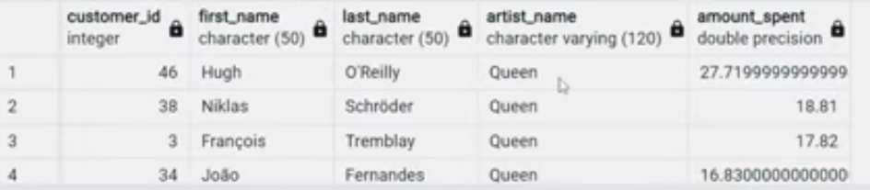

Q10: We want to find out the most popular music Genre for each country. We determine the most popular genre as the genre with the highest amount of purchases. Write a query that returns each country along with the top Genre. For countries where the maximum number of purchases is shared return all Genres.
- Steps to Solve: There are two parts in question- first most popular music genre and second need data at country level.
Method 1: Using CTE -

WITH popular_genre AS
(
SELECT COUNT(invoice_line.quantity) AS purchases, customer.country, genre.name, genre.genre_id,
ROW_NUMBER() OVER(PARTITION BY customer.country ORDER BY COUNT(invoice_line.quantity) DESC) AS RowNo
FROM invoice_line
JOIN invoice ON invoice.invoice_id = invoice_line.invoice_id
JOIN customer ON customer.customer_id = invoice.customer_id
JOIN track ON track.track_id = invoice_line.track_id
JOIN genre ON genre.genre_id = track.genre_id
GROUP BY 2,3,4
ORDER BY 2 ASC, 1 DESC
)
SELECT * FROM popular_genre WHERE RowNo <= 1

Method 2: Using Recursive -

WITH RECURSIVE
sales_per_country AS(
SELECT COUNT(*) AS purchases_per_genre, customer.country, genre.name, genre.genre_id
FROM invoice_line
JOIN invoice ON invoice.invoice_id = invoice_line.invoice_id
JOIN customer ON customer.customer_id = invoice.customer_id
JOIN track ON track.track_id = invoice_line.track_id
JOIN genre ON genre.genre_id = track.genre_id
GROUP BY 2,3,4
ORDER BY 2
),
max_genre_per_country AS (SELECT MAX(purchases_per_genre) AS max_genre_number, country
FROM sales_per_country
GROUP BY 2
ORDER BY 2)

SELECT sales_per_country.*
FROM sales_per_country
JOIN max_genre_per_country ON sales_per_country.country = max_genre_per_country.country
WHERE sales_per_country.purchases_per_genre = max_genre_per_country.max_genre_number;

Output:


Q11: Write a query that determines the customer that has spent the most on music for each country. Write a query that returns the country along with the top customer and how much they spent. For countries where the top amount spent is shared, provide all customers who spent this amount .
- Steps to Solve: Similar to the above question. There are two parts in question- first find the most spent on music for each country and second filter the data for respective customers.

Method 1: Using CTE -
WITH Customter_with_country AS (
SELECT customer.customer_id,first_name,last_name,billing_country,SUM(total) AS total_spending,
ROW_NUMBER() OVER(PARTITION BY billing_country ORDER BY SUM(total) DESC) AS RowNo
FROM invoice
JOIN customer ON customer.customer_id = invoice.customer_id
GROUP BY 1,2,3,4
ORDER BY 4 ASC,5 DESC)
SELECT * FROM Customter_with_country WHERE RowNo <= 1

Method 2: Using Recursive -

WITH RECURSIVE
customter_with_country AS (
SELECT customer.customer_id,first_name,last_name,billing_country,SUM(total) AS total_spending
FROM invoice
JOIN customer ON customer.customer_id = invoice.customer_id
GROUP BY 1,2,3,4
ORDER BY 2,3 DESC),

country_max_spending AS(
SELECT billing_country,MAX(total_spending) AS max_spending
FROM customter_with_country
GROUP BY billing_country)

SELECT cc.billing_country, cc.total_spending, cc.first_name, cc.last_name, cc.customer_id
FROM customter_with_country cc
JOIN country_max_spending ms
ON cc.billing_country = ms.billing_country
WHERE cc.total_spending = ms.max_spending
ORDER BY 1;

Output:
